List of Administrative / Supporting Staff
On Regular Basis

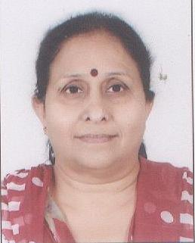 | Name : Mrs. Archna Sharma  Designation : Section Officer  Email ID: archnaa.1961@gmail.com  Mobile No.: 9711404886
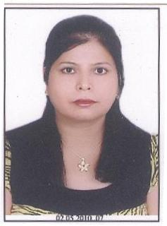 | Name: Mrs. Veenu Bhatia  Designation: Senior Personal Assistant  Email ID: vbhatia96@gmail.com  Mobile No.: 9871069006
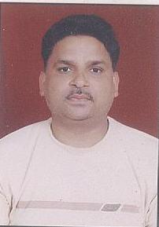 | Name : Mr. Krishan Kumar  Designation: Laboratory Superintend  Email ID: krishanacbr@gmail.com  Mobile No.: 9811730845
Name : Mrs. Kavita Dhar
Designation: Senior Technical Assistant
Email ID: kdhar2003@gmail.com
Mobile No.: 9990113621
Name : Mr. Mordhwaj
Designation: Technical Assistant
Email ID: mordhwajanand@rediffmail.com
Mobile No.: 9871045699
Name : Mr. Naterpal
Designation: Technical Assistant
Email ID: sanju_com@yahoo.com
Mobile No.:9999436174
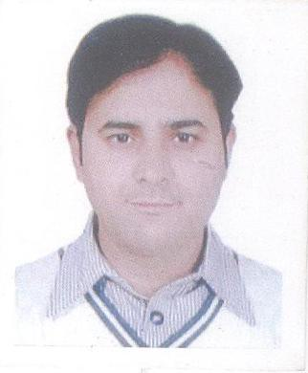 | Name : Mr. B.C. Pandey  Designation: Assistant  Email ID: vipinacbr@gmail.com  Mobile No.: 9999663594
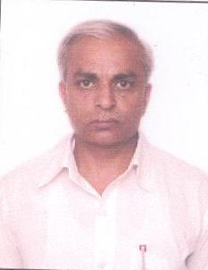 | Name : Mr. Mukesh Sharma  Designation: Lab Attendant  Email ID:  Mobile No.: 9810747888
Name : Mr. Ranvir Singh
Designation: Lab Attendant
Email ID: ranvirsinghacbr@gmail.com
Mobile No.: 8527074185
Name : Mr. Vijay Sihag
Designation: Library Attendant
Email ID: vijaybauddha@gmail.com
Mobile No.: 9211368484
Name : Ms. Chitra Joshi
Designation: JACT
Email ID: chitrajoshi@gmail.com
Mobile No.:9711318393
Name : Mr. Harish Chander
Designation: Office Assistant
Email ID:
Mobile No.: 9910792918
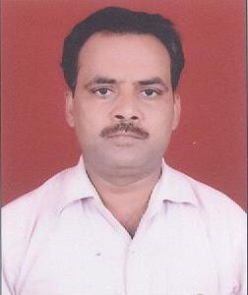 | Name : Mr. Kunwar Pal  Designation: Farash  Email ID:  Mobile No.: 9990142919
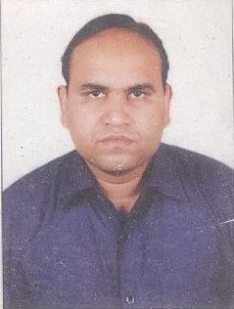 | Name : Mr. Parveen Kumar  Designation: Farash  Email ID:  Mobile No.: 9582951959
Name : Mr. Joginder Singh
Designation: Mali
Email ID:
Mobile No.: 9654706672

On Contractual Basis

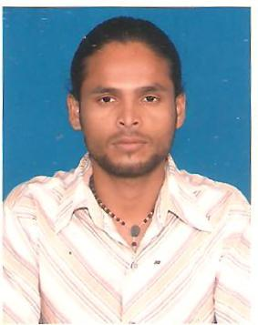 | Name : Mr. M.Jegatheesan  Designation: Programmer  Email ID: jegamcamku@gmail.com  Mobile No.: 9555161499
Name : Dr. Rajesh Kumar
Designation: Technical Assistant
Email ID: rajeshkasana83@gmail.com
Mobile No.:9899846424
Name : Mr. Sourabh Dixit
Designation: Technical Assistant
Email ID: sourabhdixit35@gmail.com
Mobile No.: 9958510826
Name : Mr. Ashraf
Designation: JACT
Email ID: ashraf201590@gmail.com
Mobile No.:
Name : Mr. Neeraj Thakur
Designation: Library Assistant
Email ID: tneeraj1977@gmail.com
Mobile No.: 9312840245
Name : Mr. Gajender Giri
Designation: Mali
Email ID:
Mobile No.:
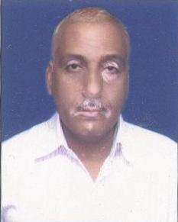 | Name : Mr. Anil Kumar Shama  Designation: Animal House Attendant  Email ID:  Mobile No.:
Name : Mr. Meetha Lal Meena
Designation: Animal House Attendant
Email ID:
Mobile No.:
Name : Mr. Ramesh Kumar
Designation: Lab Attendant
Email ID:
Mobile No.: 9718887263
Name : Mrs. Kalpana
Designation: Lab Attendant
Email ID:
Mobile No.:

